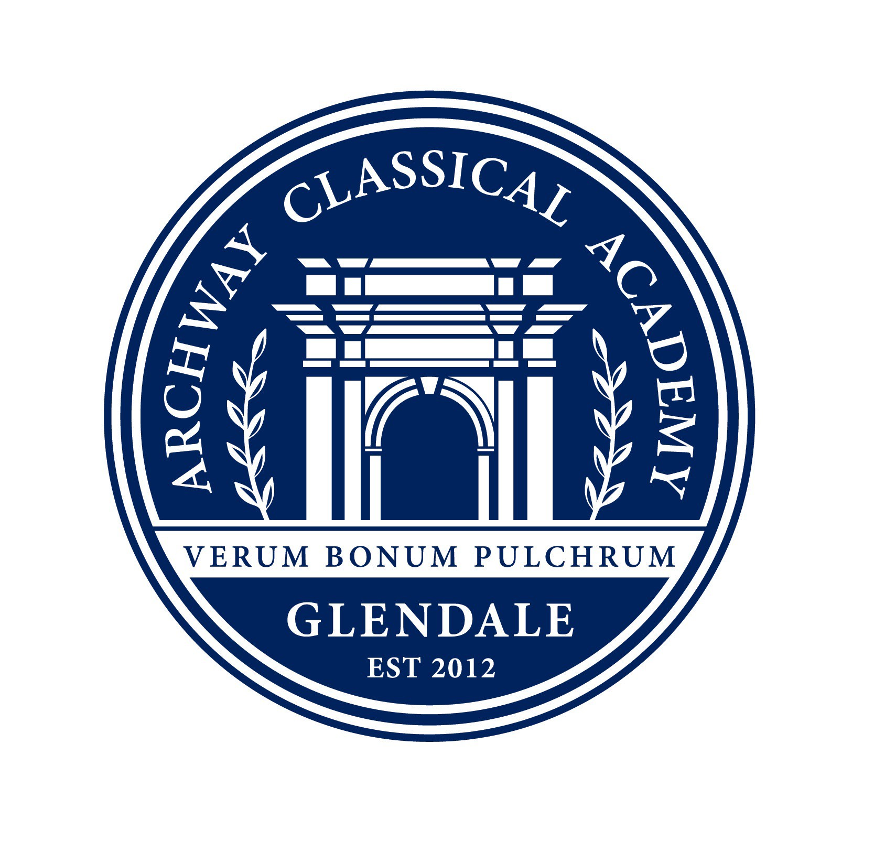
Thank you for your generous donation of $ !

Thank you for supporting Archway Classical Academy | Glendale during our 2nd Annual Fun Run. Your donation will support our playground and PE equipment, toys, and maintenance.

The Archway Glendale PSO is a 501(c)(3). EIN #46-1014697
Please keep this written acknowledgement of your donation for your tax records.

Archway Classical Academy | Glendale 23276 North 83rd Avenue | Peoria AZ 85383 | 623-866-4710

- - - - - - - - - - - - - - - - - - - - - - - - - - - - - - - - - - - - - - - - - - - - - - - - - - - - - - - - - - - - - - - - - - - - - - - - - - - - - - - - - - - - - - - - -

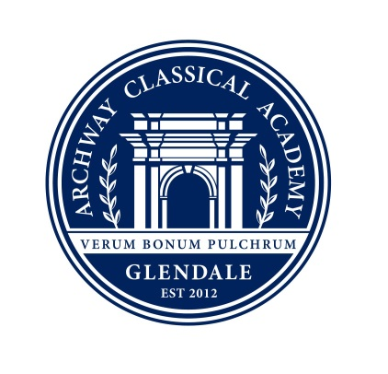
Thank you for your generous donation of $ !

Thank you for supporting Archway Classical Academy | Glendale during our 2nd Annual Fun Run. Your donation will support our playground and PE equipment, toys, and maintenance.

The Archway Glendale PSO is a 501(c)(3). EIN #46-1014697
Please keep this written acknowledgement of your donation for your tax records.

Archway Classical Academy | Glendale 23276 North 83rd Avenue | Peoria AZ 85383 | 623-866-4710

- - - - - - - - - - - - - - - - - - - - - - - - - - - - - - - - - - - - - - - - - - - - - - - - - - - - - - - - - - - - - - - - - - - - - - - - - - - - - - - - - - - - - - - - -

Thank you for your generous donation of $ !

Thank you for supporting Archway Classical Academy | Glendale during our 2nd Annual Fun Run. Your donation will support our playground and PE equipment, toys, and maintenance.

The Archway Glendale PSO is a 501(c)(3). EIN #46-1014697
Please keep this written acknowledgement of your donation for your tax records.

Archway Classical Academy | Glendale 23276 North 83rd Avenue | Peoria AZ 85383 | 623-866-4710
- - - - - - - - - - - - - - - - - - - - - - - - - - - - - - - - - - - - - - - - - - - - - - - - - - - - - - - - - - - - - - - - - - - - - - - - - - - - - - - - - - - - - - - - -

Thank you for your generous donation of $ !

Thank you for supporting Archway Classical Academy | Glendale during our 2nd Annual Fun Run. Your donation will support our playground and PE equipment, toys, and maintenance.

The Archway Glendale PSO is a 501(c)(3). EIN #46-1014697
Please keep this written acknowledgement of your donation for your tax records.

Archway Classical Academy | Glendale 23276 North 83rd Avenue | Peoria AZ 85383 | 623-866-4710

